|  |
| --- |
|  |
|  |

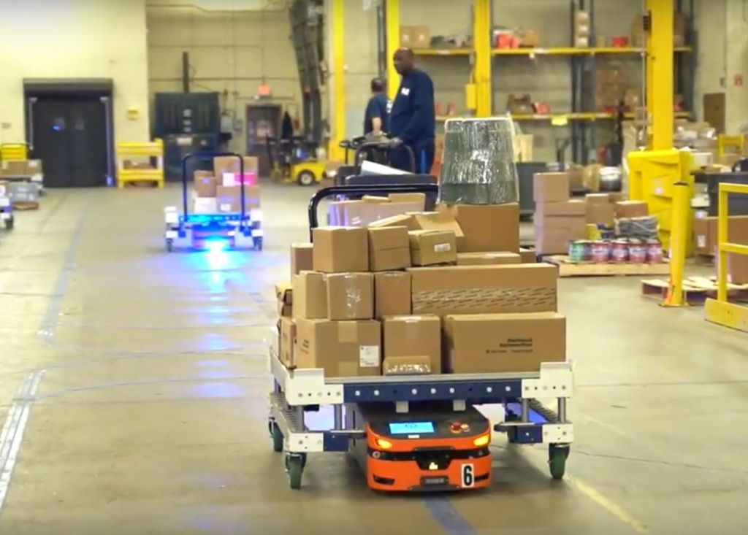MATERIAL HANDLING

CHETHAN

4nm19me025@nmamit.in

# Material Handling

According to “Safework” Australia’s latest workers statistics, “body stresses” (related to lifting or carrying heavy objects) is the leading cause of injuries in the workplace. The ideal way to avoid these types of injuries is to have the right material handling equipment (cart, a trolley, crane, portable clamping stand, etc.) along with a highly professional and well-trained staff. Moreover, having good material handling can help us have a safe warehouse since your staff will waste less time and energy lifting objects. That way, we would be able to keep them safe and more productive, while being able to save some money.

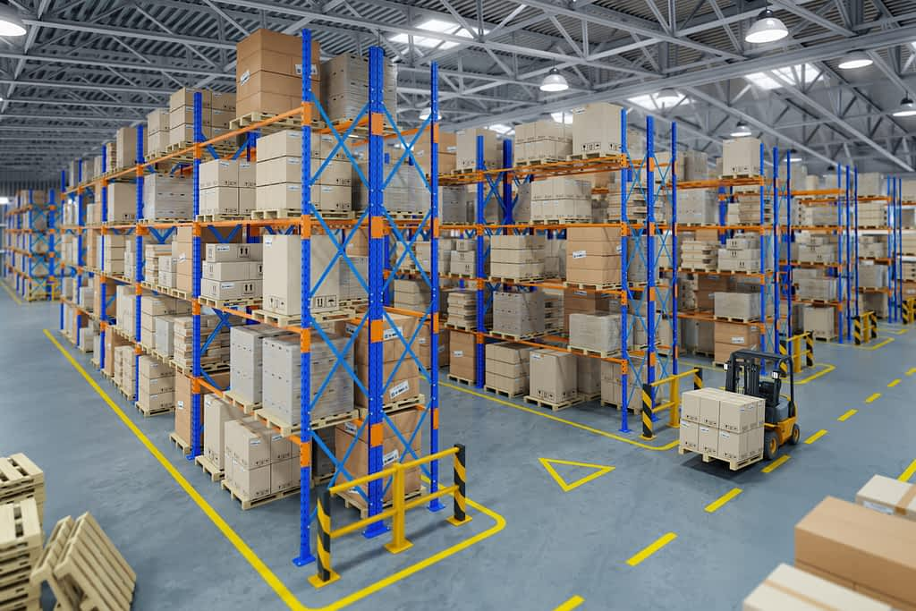

There is not a single company that wants to deal with product loss or damage in their warehouse since this is sure to decrease their profit as well as their reputation. That is why you need to prevent this by implementing good material handling equipment. Except for being able to lift and carry more things at once (which gets the job done more quickly), handling materials the right way can help you keep your warehouse more organized and that leads to prompt service and higher customer satisfaction.

Lastly, having your products neatly organized can not only create a safe working environment for your employees, but also provide easy access. Providing your employees with a safe environment will also result in them being less absent and more efficient, as well as to remain motivated to work. In addition, they’ll also have a lower risk of long-term illness.

All in all, investing in this type of equipment is a smart decision and quite beneficial to the business as a whole, including both the customers and the workers (and for you as an owner too) which in turn is to result in a general peace of mind and security.

Material handling has improved immensely since it started as fully manual operations, where men were employed to lift, stack, tote, and count (Pence, 1994). Employees transporting materials using powered equipment, such as a powered-jack or pallet truck, result in additional non-value added costs to a product. Please refer to Figure 1 to see examples of traditional human operated material handling. The purpose of this document is to inform the reader about alternative material handling solutions. These solutions include Automatic Guided Vehicles (AGVs) and Autonomous Mobile Robots (AMRs). This document provides a technical background for AGVs and AMRs with in-depth cost-benefit analyses to better understand the applications of robotic material handling systems.

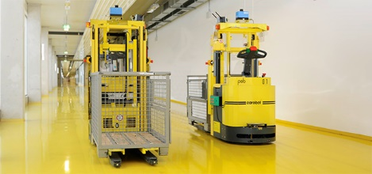 The first step in automating material handling occurred in the 1950s with the implementation of Automatic Guided Vehicle Systems (AGVS). AGVS are defined as battery-driven industrial trucks with contactless steering (Müller, 1983). These trucks operate by following a guided system to transport materials throughout a facility. This AGVS is guided by a floor path. As defined by Müller (1983), the main components of AGVs consist of:

* The truck or tractor, pallet truck.
* The floor system with the installation of the wire guidance system and the information transfer system.
* The load transfer equipment which can be both on board the truck and/or in a stationary position, including the station structure.

The Material Handling Robot

The Material Handling Robot refers a type of system that can be used in production as well as in other industries etc. This system includes a battery operated remote sensing locomotive (carrier) on which a small lift is provided, specific path over which it moves, sensors for sensing the obstructions on the path of the carrier. Also sensors for sensing exact positions from where load wants to carry and to where. The Material Handling Robot moves using the electric power from the battery. It moves with a low and constant speed on the prescribed path. The path has a specific color (black). The bottom of the carrier have sensor which is always coupled with the path. The steering is done by the path. The front side of carrier vehicle contains sensors for sensing the obstructions on the path. As it reaches the unloading station, it is stopped and unloading of the material is done at that station. And move to collecting stations again. Continues working cycles for making this project a reality. By this there is ease in transporting materials or finished products from one work station to the other.

There are many reasons which yield to the creation of Material Handling Robot (MHR) around the world. Mostly the reason is to overcome the logistic problems that often occurred in the workplaces and to make improvement to the facilities provided in the workplaces. Usually the MHRs are implemented in factories, hospitals, offices, houses, and even can be found anywhere outdoors without the people surround realized it. In the industries or factories, the MHRs can ease the physical strain on human workers by performing tiring tasks, such as lifting and carrying heavy materials, more efficiently with no signs of fatigue creeping in. They can carry far more than human workers, and their movements can be tracked electronically at all times. Their movements can be timed to feed or collect products or materials from the work cells in the factories PATH DECISION MHRs have to make decisions on path selection. This is done through different methods: frequency select mode (wired navigation only), and path select mode (wireless navigation only) or via a magnetic tape on the floor not only to guide the MHR but also to issue steering commands and speed commands.

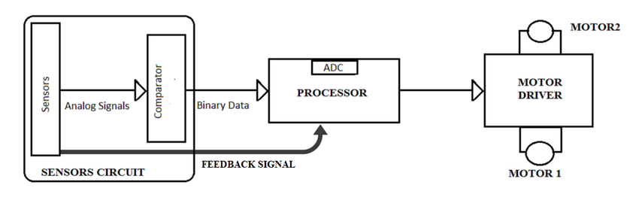

The Basic Block Diagram of the MHR consists of 3 blocks as showing in the figure, namely,

1. Photo Logic Optical Sensor Module.

2. Microcontroller Module.

3. Motor Control Module.

COMPONENTS OF MATERIAL HANDLING ROBOT

1. MECHANICAL PARTS

The Mechanical components includes,

* Chassis
* Steering system
* Ultrasonic sensor for obstacle detection
* Chassis:

• Act as a frame for attaching other components

• Carry the load of other components and the payload.

• Act as sacrificial component to prevent damage of expensive payload in case of accidents

* Steering System:

Steering system is for steering the Material Handling Robot. The two individual motors are directly attached with the rear wheel for steering and a single Castrol wheel is at the front.

* Ultrasonic sensor for obstacle detection:

In controlling and designing Material Handling Robot (MHR) systems the problem of prevention of MHR collisions and deadlocks should be addressed. By attaching ultrasonic sensors on MHRs, physical collisions can be avoided. An MHR should have the ability to avoid obstacles and the ability to return to its original path without any collisions.

2. ELECTRICAL COMPONENTS

Electrical components include the motor and the power supply unit for the motor, sensing unit.

* DC MOTOR

100 RPM DC Motor with Gearbox generally used for robotic application are used for the driving mechanism, steering mechanism and lifting mechanism. We can adjust it to desired RPM using gear box. Very easy to use. It is excellent for line tracking robotic application.

* BATTERY

The power required for the entire working process is given by a Rechargeable valve regulated Lead-Acid battery. The power from the battery is split it into two and one part is given to microcontroller, display unit, driving unit and other part is given to lifting motor.

END